General Geology and Soils

An overview of the general glacial stratigraphy and geologic history of this region is provided below followed by a detailed overview of the specific stratigraphy lying below and proximal to the subject property.

Approximately 18,000 years ago the Cordilleran Ice Sheet reached the Fraser Lowland and a lobe flowed west into the Strait of Juan de Fuca and south into the Puget Lowland (Puget Lobe). As the Puget Lobe dammed the north flowing streams within the lowland, a proglacial lake system developed in topographically low troughs within Puget Lowland. Glacial-lacustrine (lake) sediment was deposited in these proglacial lakes and is locally defined as the Lawton Formation. The Lawton Formation consists of gleyed, laminated clays, with sporadic ice-rafted dropstones, and has a very low permeability. The Lawton clay forms relatively shallow aquicludes throughout the region. Within such aquicludes subsurface water becomes perched and reaches the surface as seepage springs along many of the bluff slopes. The discharge rate along these types of seepage springs depends largely on the sediment characteristics of the aquifer (i.e., Esperance outwash vs. Vashon Till) and overlying substrate (i.e., porosity and permeability) of the recharge area.

As the Puget Lobe advanced south, advance outwash deltas and plains were prograded into proglacial lakes and upland surfaces. The advance outwash unit, locally defined as the Esperance Formation, consists of well-sorted, stratified sands, and typically lies below the Vashon till. Slopes comprised of sandy outwash maintain an angle of repose of about 33-35°, but can be steeper when damp and internal cohesion is higher.

As the Puget Lobe advanced south to its terminal position near Olympia, Washington, the Vashon till was deposited over much of the pre-existing landscape. Pre-glacial topography played an important role as to whether glacial erosion or deposition processes dominated the landscape. In pre-existing topographic lows (i.e., Puget Sound troughs) where ice converged, glacial erosion dominated, and the interglacial and advance units were eroded and the Vashon till was deposited unconformably over these surfaces during retreat of the Puget Lobe. Where pre-existing topographic highs existed, ice flow diverged around these structures and till was deposited when pressure melting increased. The advance history of the Puget Lobe is preserved in bluff exposures lying south of the subject property.

Retreat of the Puget Lobe from the Puget Lowland was characterized by both rapid calving in lacustrine (south of Whidbey Island) and marine embayments (proximal and north of Whidbey Island), as well as ablation of grounded ice from the upland surfaces. During deglaciation, the Puget lobe retreated to a point north of Oak Harbor, and then subsequently readvanced south, to a location near the south shoreline of Penn Cove and easterly shorelines of Harrington and Race Lagoons (see DEM, Fig. 9). A broad hummocky moraine, north of Penn Cove and two ice-marginal deltas prograded to the southwest, delimits the terminus of this readvance. It is evident from the glacial geologic record that ice remained in this recessional position for a period of time long enough to

prograde the large glacial marine deltas. The horizontal topset beds of the post-glacial marine deltas were graded to sea level during this time (~ 15,000 years ago) and form the present day surfaces of Smith and Ebey Prairies. The topographic expression of these deltas is clearly defined on the 7.5 minute topographic map (Fig. 10) and DEM (Fig. 9). Following deglaciation, Whidbey Island was isostatically depressed (due to ice loading) during which time a marine incursion occurred into the Puget Lowland. The topset beds of the post-glacial marine deltas were graded to relative sea level, which was ~200 feet above modern sea level (Fig. 10). Initially, the rate of isostatic uplift was greater than eustatic sea level rise, which resulted in the formation of a series of post-glacial marine terraces incised into the pre-existing substrate as the land emerged. These terraces are well preserved along the north shoreline of Penn Cove. The gently sloping portion of the subject property is formed on one of these lower post-glacial marine terraces. The steep bluff slope of the subject property represents an ice-contact surface formed at the delta head.

The subject property is located directly northwest of the ice-contact head of the southeasterly delta (Fig. 9). The inferred substrate geology is described in the stratigraphic section shown in Figure 11.

The lower substrate units of the subject property are composed of ice marginal sediment flows and melt out facies (Figs. 11 and 12). The lowermost part of the exposed section is composed of a stratified diamicton (flow till), which is characterized by deformed bedding and considerable variability of the matrix mixture, clast abundance and the thickness of the unit. The flow till likely originated directly from the ice or reworking of Vashon till as it was deposited into a marine embayment during retreat of the glacier from Penn Cove.

To the north of the subject property, the unit is more massive near the base of the slope with sedimentological properties similar to basal till (Fig. 13). It is likely that the ice margin was receding by ablation in shallow water and that the till was deposited directly beneath the receding ice at this contact. As the ice retreated from its recessional limit, proximal meltwater fan sediment was deposited over the stratified and massive diamicton facies. This unit is exposed in the upper thirty feet of the section proximal to the subject property (Figs. 11 and 14). The proximal meltwater fan unit consists of stratified sands and silts with trough cross-stratification, indicating deposition by channelized flows. Bedding tends to be discontinuous and grades to ice-rafted pebbly mud and silty units (ice-rafted facies), which comprise the upper 10 to 20 feet of the section (Figs. 11 and 14). The ice-rafted facies was likely deposited by melt-out of icebergs as the calving ice sheet retreated from the northern Puget Lowland. The more massive section (i.e., contain no laminations) of the ice-rafted facies look similar to the Vashon till, but generally have a higher percentage of fines (silts and clays) within the supporting matrix. The ice-rafted facies appears more buff colored than the gray Vashon till and possesses a characteristic blocky weathering structure, easily observed in bluff exposures. In some exposed sections, the ice-rafted facies contains marine fossils (e.g., pelycepods, barnacles, bivalves) supporting its inferred glacial marine origin. The uppermost 2-5 feet of the exposed section is composed of a moderately well-sorted, post-glacial, beach lag that

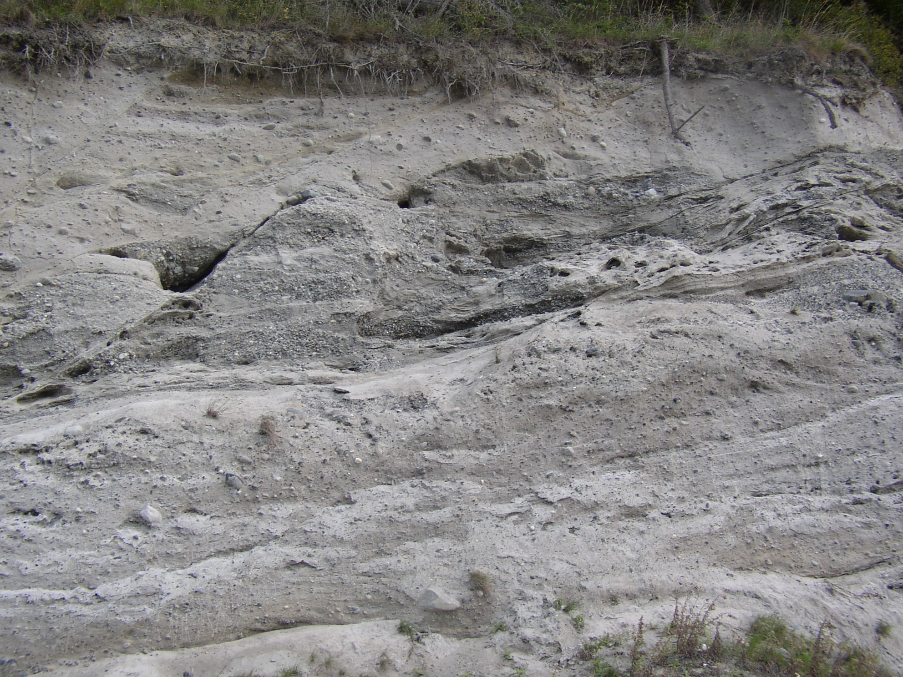

Figure 12: The lower substrate unit of the subject property is composed of ice marginal sediment flows and melt out facies. The lowermost part of the exposed section is composed of a stratified diamicton (flow till), which is characterized by deformed bedding and considerable variability of the matrix mixture, clast abundance and the thickness of the unit.

Figure 13: Along the shoreline north of the subject property, the ice-marginal facies is more massive near the base of the slope with sedimentological properties similar to basal till.

emergent facies
ice-rafted marine drift
ice-marginal sediment flows
proximal meltwater fan facies

Figure 14: A small colluvial landslide lying north of the subject property exposes the entire glacial marine drift section. Ice-proximal sediment (till) flows are found in the lower section. Meltwater fan and ice-rafted facies are found in the upper 20 to 30 feet of the section. Following deglaciation the marine basin isostatically emerged and a beach lag was deposited over the glacial marine drift facies at elevations (~200 feet a.s.l.) below the marine high-stand for this region.

formed by wave and tidal processes as the marine basin emerged (emergent facies) during isostatic recovery (Figs. 11 and 14). This unit has a relatively high porosity and permeability (see soil log in Appendix 2); thus, infiltration rates tend to be high and surface runoff low. The percable soils reported in Appendix 2 are found within this unit.

The deltaic units (foreset and topset beds), comprising Smith and Ebey Prairies, were deposited by prograding outwash streams that were flowing from the glacier into a shallow marine embayment to the southwest. The subject property lies northwest of the delta head and the stratified deltaic units are not exposed in the bluff section lying below it. Outwash from the retreating ice sheet buried stagnant ice near its terminal zone, leaving the distinct “pock-marked” kettle and kame topography lying west of Penn Cove, and represents collapse structures which formed as the buried ice melted out (DEM, Fig. 9).

Water and Drainage

The emergent facies directly underlying the subject property has a relatively high permeability and porosity. Surface runoff on this unit is low while water infiltration rate into the ground is high; thus, most of the surface water falling onto the proposed building and drainfield sites will likely infiltrate the permeable substrate and make its way to the Puget Sound via subsurface flow. The geologic units underlying the emergent facies (i.e., proximal meltwater fan and ice margin sediment facies) have numerous discontinuities and varied permeability and porosities. Overall, it is apparent that these underlying units do not form well-defined aquicludes below the subject property, likely because the fine-grained facies are not horizontally continuous at depth. There were no obvious perched seepage springs along the bluff slope direictly below the subject property. Swordtail fern, salal and elderberry are common understory plants growing on subject property, attesting to its good drainage. There are no major drainage catchments near the subject property that concentrate surface or subsurface runoff onto the bluff slope. The nearest major catchment lies to the northwest of subject property and drains east into Harrington Lagoon (See 7.5 minute topography map, Fig. 10).

Shoreline

The shoreline lying below the subject property is a relatively moderate-energy beach environment protected by a tidal berm as well as being situated to the lee (east) of the prevailing winter storm track (southwesterly track). Inspection of the shoreline reveals minor erosion directly below the subject property. The slopes lying directly below the subject property are continuously vegetated and show no evidence of recent landslides. A tidal berm provides protection for the base of the slope from being over-steepened and undermined by wave erosion (Fig. 15). During high tides coupled with severe winter storm events, waves can reach the base of the slope as shown by wave-transported debris at the base slope (Figs. 5 and 16). Wave erosion become more prevalent as one travels north of the subject property. Bathymetric (length of wave-cut platform at low tide/time since glaciation) and vegetation age data suggest that the overall retreat rate of the bluff slope directly lying below the subject property is relatively lower than that calculated for shoreline lying north of the subject property.

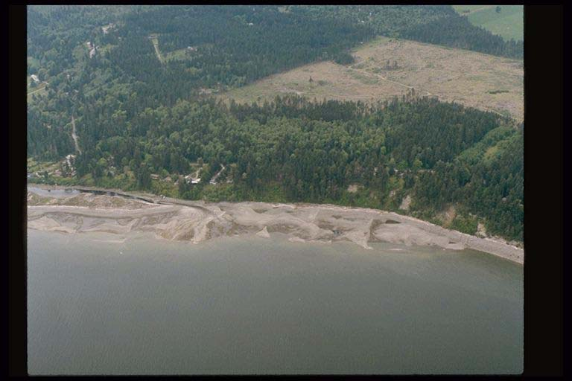
Smith Prairie
subject property
Harrington Road
longshore current
Race Lagoon
Figure 15: Aerial photograph of the shoreline lying north of Race Lagoon. Note that the slope lying directly below the subject property is continuously vegetated and shows no evidence of recent landslides. Landslide (scarps shown with red arrows) activity increases on the slopes lying north of the subject property. Littoral drift currents (shown with blue arrow) are predominantly S to N during both summer and winter seasons.
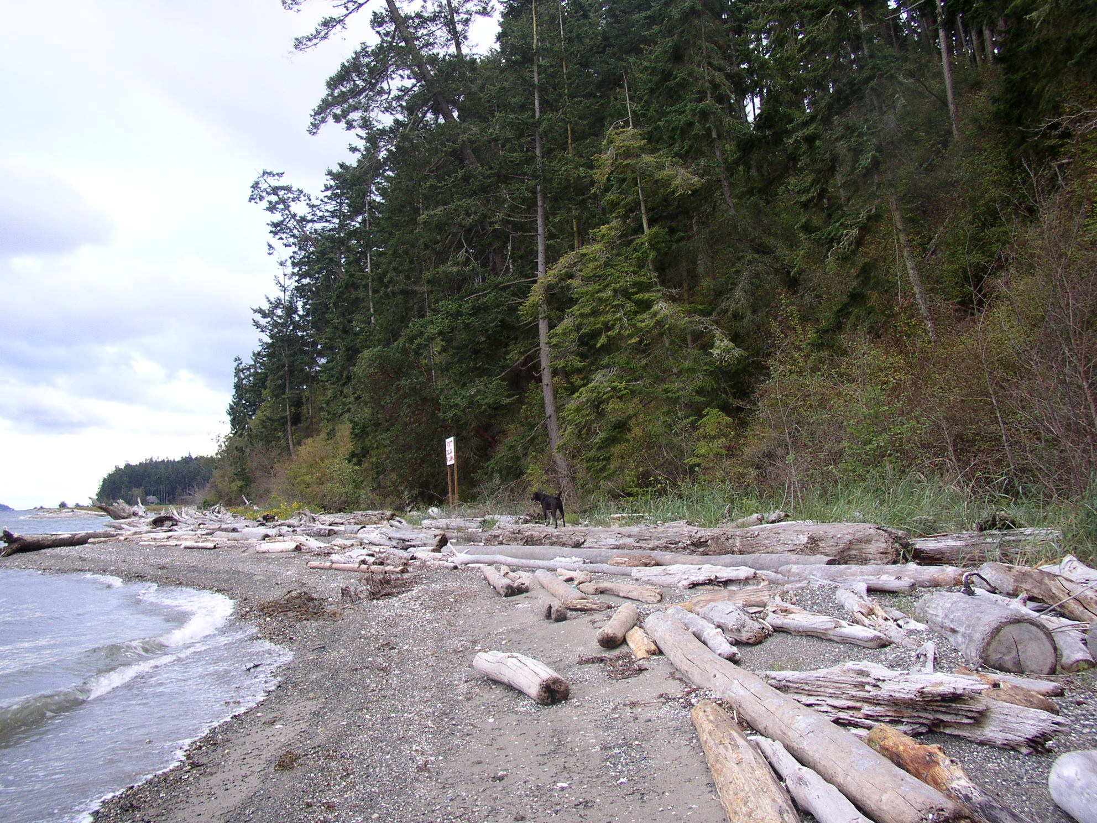
Approximate north boundary of the subject property
Figure 16: The shoreline adjacent to the subject property is accreting and consists of mixed medium materials (sands and gravels). The shoreline is armored with drift logs and protected by a tidal berm. This image is taken from the shoreline lying north of subject property looking towards the south. Race Lagoon appears in the distant background.

The existing shoreline is accreting, directly fed and comprised of mixed medium material, predominantly sands and gravels (Fig. 17; WA State Coastal Geologic Atlas). Most sediment deposited along the shoreline is derived from eroded bluff sediment and existing shoreline sediment transported by littoral drift currents and reworked by local wave action. Littoral drift currents transport sediment from a southerly to northerly direction (Fig. 17; WA State Coastal Geologic Atlas). Littoral drift shoreline transport rates vary between ~25 thousand cu. yards in the winter season (Nov. – Apr.) and ~5 thousand cu. yards in the summer season (May – Oct.) adjacent to the subject property Fig. 17).

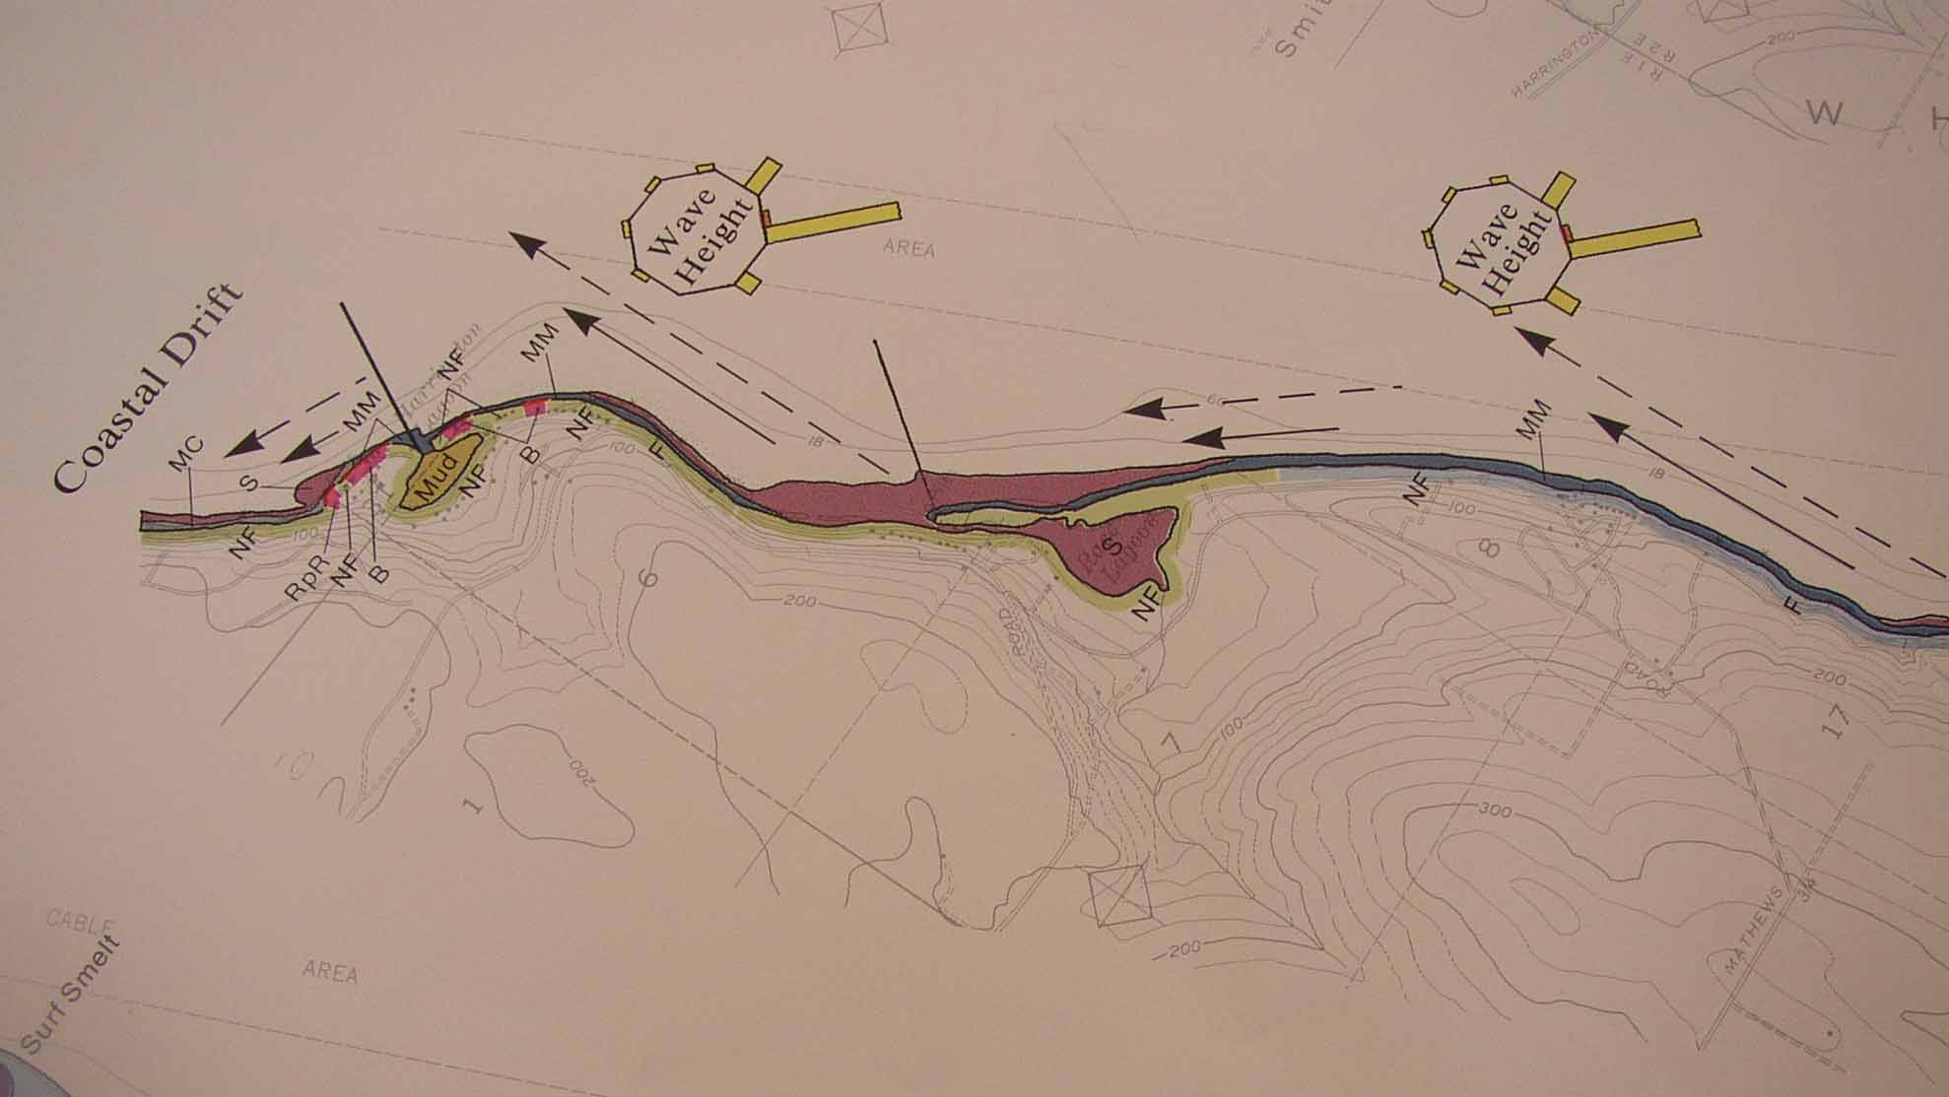
Subject Property

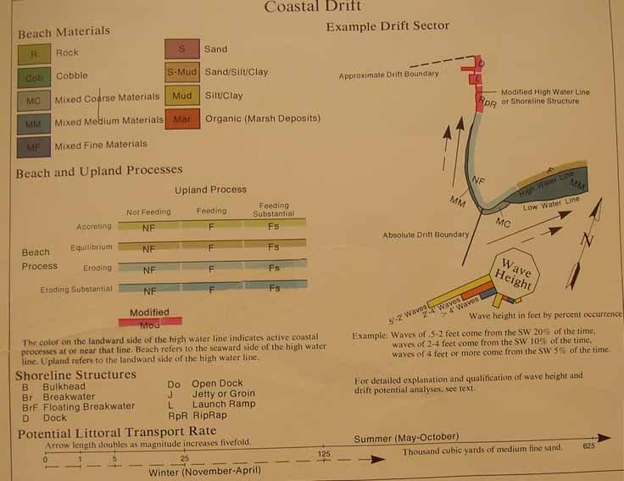
Figure 17: Coastal geologic map of the Harrington Lagoon area and legend (Taken from Coastal Geologic Survey Vol. 4 for Island County.

Slope Characterization and Stability

The westerly half of the subject property consists of a buildable portion situated on a relatively flat post-glacial marine terrace sloping 3-5° in a easterly direction (Figs. 1 and 2). The easterly half of the subject property consists of a high-bank bluff slope (~60-70 feet relief) and adjacent moderate-energy shoreline (Figs. 1, 3 and 4). The steepest portion of the bluff consist of a slope at or near its angle of repose (40-50°). A steep slope break line was established where the slope angle exceeds 30° (Figs. 1 and 11).

Excepting the aforementioned recent colluvial slides lying north of the subject property; no evidence of major slope instability was observed proximal to the subject property. The toe of the slope is protected by a tidal berm and is afforded some protection. Such shallow-seated slides are common in the Puget Sound region where soil (colluvium) overlying less permeable parent geologic substrates on steep slopes becomes saturated or undermined by wave processes. Evidence of such historical slide activity is difficult to observe because new vegetation quickly becomes re-established following the mass wasting event. The age structure of the slope vegetation can provide some information regarding the frequency of such events. The fact that the subject property’s upper slopes behind the tidal berm have mature conifers growing attests to their relative stability. The shallow slides observed to the north of the subject property are related to mass movement of shallow colluvium overlying impermeable glacial marine drift units that is undermined by wave erosion. These types of mass wasting events are common, but pose minimal threat to the upslope property.

A retreat rate for the bluff slope lying directly below the subject property can be estimated by measuring the width of the wave cut platform at low tide (-18 ft. bathymetric contour, Fig. 10) divided by 13,000 years, the time since relative sea level was near that of today. This calculation yields a bluff retreat rate of ~650 ft/13,000 yr = 0.60 inches per year. This calculation is likely a minimum estimate for the modern bluff retreat rate for this location because bluff retreat likely increased following post-glacial eustatic sea level rise between 13,000 and 7,000 years ago when sea level eventually stabilized. The fact that the bluff slope directly below the subject property remains vegetated with mature conifers and still retains old-growth stumps attests to its relative stability over the past few centuries and that the recent retreat rate may be less than the Holocene average (Fig. 18).
Figure 18: The fact that old-growth stumps are still preserved on the subject property’s upper bluff slope attests to its relative stability over the past few centuries.
Since the toe of subject property’s slope is not actively being undermined by wave processes, its slope is at or near the angle of repose for glacial marine sediment. Because little perched spring water discharges directly onto the slope, the underlying geologic substrate is competent, mature conifer trees grow relatively straight on the slope, and little evidence of recent landslide activity exists directly below the proposed building site, together, indicate that the subject property’s slopes have been relatively stable over historical time. However, since the subject property’s slope is comprised of shallow colluvium overlying unconsolidated glacial marine sediment, future colluvial slides are a possibility during excessively wet winters; thus, a building setback line is still warranted from the bluff line. A 40-foot minimum setback from the bluff line, as indicated on the site plan (Fig. 1) and cross section (Fig. 11), will allow an adequate margin of safety in the event that a future surface slide or slump occurs. Such slides are likely to be small in surface area and shallow-seated. As stated above, there has been no recent slide activity directly below the subject property.

Slope stability analysis of this site during an earthquake is not within the scope of this report. It is difficult, if not impossible to predict the potential impact of a major seismic event on any particular slope because of the many variables that affect earthquake intensity at any given location (i.e., proximity to the epicenter, magnitude of earthquake, substrate conditions, direction of propagating seismic wave, moisture conditions of the slope, etc.). However, a general rule of thumb can apply to slope setbacks and margin of safety: the greater the building setback from a steep slope, the greater the margin of safety for any structure lying proximal to that given slope. Consequently, choosing a building setback greater than the minimum recommended will provide greater insurance against potential structural damage resulting from a potential seismically-induced slope failure.

Vegetation

The proposed building and drainfield sites consist of 2nd and 3rd growth Douglas fir and scattered western red cedar forest with associated understory vegetation. Several old growth fir stumps exist on the upland and lower bluff slope attesting to their stability (Fig. 18). The bluff slope is also vegetated with fir and scattered cedar trees. The trees growing on the gently sloping portion of the subject property and its bluff slope are mostly straight although some show some slight tilting (Figs. 2 and 5) due to normal soil creep processes. The bluff slope lying north of the subject property has younger succession species and parts remain bare indicating that shallow colluvial slides have occurred during abnormally wet years or the result of being undermined by wave erosion (Fig. 15).

The role of vegetation is important in slope stability. The roots of plants and trees bind the soil particles and anchor the soil mass to the slope, reducing soil creep and the occurrence of shallow slides. Evergreen vegetation intercepts and diffuses surface water directly on slopes, preventing erosion during intense precipitation events. Vegetation has also been noted to remove some shallow ground water through transpiration; however, this process is minor during the wettest winter months when deciduous trees lose their leaves and growth processes in the confer species is reduced. A dense vegetation growth should be encouraged on the bluff slopes, especially those species better suited for erosion control. Vegetation species that are deep rooted (e.g., Douglas fir, Western Red Cedar, Pacific Yew, Vine and Big leaf Maples) are better suited for improving slope stability and erosion control than shallow-rooted species, particularly, red alder. A more comprehensive list of vegetation suitable for erosion control is provided in “Vegetation Management: A guide for Puget Sound Bluff Property Owners” (Manashe, 1993). This guide book can be obtained free of charge from Island County Public Works.

The existing conifer trees should be maintained on the subject property as much as possible, providing they do not compromise the safety of the proposed residence from windfall. Conifer species lying east of the proposed building site may be limbed to provide “view windows” for the future residence. At least 50% of the crown should be maintained to ensure the health of the tree. Some conifer trees will need to be removed for construction of the future drain field and home site. This removal on the gently sloping portion of the subject property should have minor impact on drainage and erosion processes, providing the drainfield is reseeded with grass or clover and that the roof, foundation and driveway runoff is collected and dispersed into several dry wells. The dry wells will need to be monitored during the wet season to ensure that the ground is able to absorb the runoff created from the impermeable surfaces. If the ground cannot adequately absorb the created runoff then it will need to be tight-lined directly to Saratoga Passage using engineered HDPE outflow pipe.

Road Setback and Access

Harrington Road has a building setback of 20 feet from the right-of-way or 60 feet from the road centerline, whichever is greater. Since the proposed home site lies greater than 75 feet from the road right-of-way, the future residence will be constructed well outside these setbacks. An access permit will need obtained (if not already obtained) from Island County Public Works prior to or concurrently with the submittal of a building permit.

Water Availability

The current property owner has requested that I assess the feasibility of expanding a single-party well/system that serves his neighboring property (to the south) to a two party well that would include the subject property. I consulted with the Island County Department of Health to discuss this proposal and was given the criteria necessary to perform such an expansion. Since the subject property is unable to connect to an existing approved water system, then it may be possible to supply its water needs using the existing single-party well supplying the owner’s cabin lying several parcels to the south (315 Harrington Road). A number of criteria and Island County Health Department requirements are necessary to be met. I have attached the “Guide for Approval of Public Water Supply for Two-Party Wells” to this report (See Appendix 3).

III. RECOMMENDATIONS

Setback - A minimum building setback of 40 feet from the steep slope line, as shown on the attached site plan (Fig. 1) and cross section (Fig. 11), is recommended. Deck post footings may be within the setback area. If the drain field and reserve sites do not require too much of the upslope area, then I would recommend that the future bluff setback be even a greater distance from the bluff line than minimum value reference above.

Foundations – The proposed future residence has not been designed and I have not seen specific plans regarding any foundation plan. In any event, it is important that the house foundation/footings should be set into undisturbed competent parent material. For most designs the underlying, undisturbed glacial units are structurally competent to support most loads without major compaction.

The foundation drainage should consist of 4 inch perforated pipe, surrounded with drain rock or pea gravel, all wrapped in filter fabric. Certain ”landscape” fabrics do not allow sufficient infiltration of water into the pipe, or tear easily. A designed filter fabric, such as Mirifi 140 NL, other similar product, may be more suitable. The foundation drain should have a minimum 2% slope and the pipe should be set with no dips. The foundation drain should be tied in with the roof drain and tight-lined to the Puget Sound. Specific design characteristics of the foundation drain will be submitted with the house plans prepared by the architect/designer.

Excavation and Fill - The permeable upper substrate unit (beach lag) may be suitable for general on-site fill, but not suitable for backfilling behind the foundation wall. Backfilling behind the foundation wall should be of free-draining granular material, such as coarse sand. The lower substrate unit (ice-rafted glacial marine drift) is not suitable for on-site fill because when wetted, the high silt and clay content of the matrix causes it to liquefy, particularly when under vibratory compaction. Keep in mind, that the high silt and clay content of glacial marine drift does not make it an ideal material for landscaping purposes either. No fill should be placed on the bluff slope. The respective drainage properties of the underlying substrate will need to be evaluated during excavation of the foundation, as the depth and thickness will vary from that exposed along bluff.

Drainage and Grading – Future drain field and residence construction will require excavation and clearing to bare ground. Appropriate drainage and erosion-reduction practices will need to be implemented downslope from the construction site. A siltation fence should be placed on the edge of the cleared building area to trap excess sediment from being washed from the bare soil during precipitation events. This fence should be monitored and maintained throughout the construction period.

Surface water collected from the driveway, roof and foundation drains should be collected and diverted to several drywells, constructed at least forty feet westward of the existing bluff line. The underlying geologic substrate (emergent facies) should have a high enough permeability and porosity to adequately disperse the collected surface water and allow it to slowly infiltrate at depth and safely reach Saratoga Passage via through flow. Since a walking trail is present along the entire bluff slope, changes in discharge from potential seepage springs can be monitored throughout the winter months to ensure that seepage water does not reach the bluff slope along a minor aquiclude that is buried beneath the colluvial cover. If the proposed home and driveway have a large footprint, then it may be prudent to simply tight-line the runoff directly from the drywells to Saratoga Passage without any future monitoring of the slopes for increased discharge along potential seeps. Since no current plans exist for the future residence, the potential impact of its construction on drainage/erosion is difficult to evaluate at this time.

If it is determined that drainage runoff reaches the slopes and causes potential loading and reduction of cohesion, then I would recommend that this surface water be collected and tight-lined directly down the bluff slope into Saratoga Passage using small diameter (4 inch) HDPE outflow pipe. It may also be necessary to construct a rock or concrete outfall collection pad at the toe of the slope to ensure that the base of the bluff slope is not excessively eroded by this additional runoff. Large cobble-sized rocks that are found along the beach could be easily collected to serve this purpose. In the event that a drainage system is necessary, it will need to be properly engineered and be approved by the appropriate by Island County governmental authority (e.g., Public Works and Planning and Community Development).

Vegetation – Some mature conifer species will need to be removed for construction of the drain field and building site. They can be thinned on the upslope portion of the property to remove potentially dangerous trees near the proposed home site. Mature conifer species growing on the bluff slope may be limbed for view purposes providing at least 50% of the crown is preserved. Alders or maples may be topped or limbed to maintain the present view pathway. No major equipment should operate on the bluff slope. Cut trees, limbs, grass cuttings, brush or other organic matter should not be deposited on the steep slopes.

IV. LIMITATIONS
10B

The conclusions and recommendations reported herein are based on visual examination of the site. These conclusions and recommendations are professional geological opinions only. No warranty is expressed or implied. As a condition of our services, it is understood that, to the fullest extent permitted by law, our clients agree to defend, indemnify and hold harmless Whidbey Geological_{LLC} its owners, employees and agents, from any future claims or damages at the site, including potential claims from third parties that may name Whidbey Geological_{LLC}, its owners, employees or agents as a claimant.

V. BIBLIOGRAPHY

Atwater, B.F. 1997. Coastal Evidence For Great Earthquakes in Western Washington. U.S. Geological Survey Professional Paper 1560, 77-90.

Easterbrook, D.J., Blount, D., and Rutter, N. (1987). Chronology of Pleistocene Sediments in the Puget Lowland, Washington. Washington Division of Geology and Earth Resources Bulletin, 77, 321-353.

Gerstel, W.J., Brunengo, M.J., Lingley Jr., W.S., Logan, R.L. Shipman, H., and Walsh, T.J. 1997. Puget Sound Bluffs: The Where, Why, and When of Landslides Following the Holiday 1996/97 Storms. Washington Geology 25, 17-31.

Menashe, E. 1993. Vegetation management: A guide for Puget Sound bluff property owners. Washington Department of Ecology Shorelands and Coastal Zone Management Program Publications 93-31, 46 p.

Porter, S.C., and Swanson, T.W. 1998. Advance and Retreat rate of the Cordilleran Ice Sheet in southeastern Puget Sound Region. Quaternary Research 50, 205-213.

Swanson, T.W., and Caffee, M. (2001). Determination of 36Cl production rates from the Deglaciation History of Whidbey and Fidalgo Islands, Washington. Quaternary Research 56, 366-382.



Appendix 3

